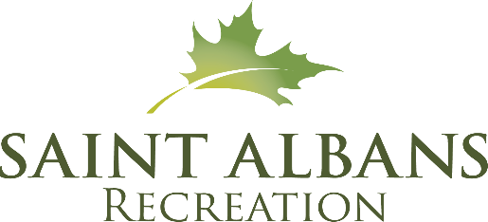

ATHLETE CODE OF CONDUCT

I, ________________________________________________,as a member of the Sharks Swim Team with the St. Albans Recreation Department understand the following statements and will abide by them.

*No swimmer will be allowed in the water until they have read, signed and agreed to this code of conduct.*

I will be respectful to my teammates, officials, opponents, parents, spectators and coaches at all times.

I will use appropriate language and tones and be gracious in victory and defeat.

I will learn the value of commitment by participating in as many practices and meets as I can.

I will arrive at practice on time and be ready to dedicate my attention to my coaches.

I will encourage my teammates and praise their efforts.

I will be respectful of my teammates’ feelings and personal space.

I will treat others as I would wish to be treated.

I will be honest, fair and truthful.

I will demonstrate good sportsmanship at all practices and meets.
I will set a good example of behavior and work ethic for my younger teammates.
I will show respect for all facilities and other property (including locker rooms) used during practices, competitions, and team activities.
I will refrain from foul language, derogatory/racist comments, violence, and any behavior deemed dishonest or offensive.
I understand that if I violate this code of conduct, I will be subject to disciplinary action and/or dismissal from the team.

____________________________________ _________________________
Signature Date

____________________________________
Witnessed

