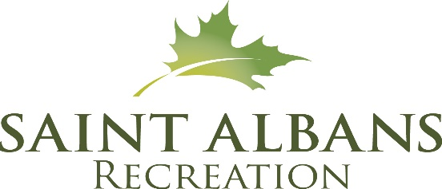

For the 3rd year in a row, Northwest Access TV is live streaming the Duct Tape Derby so people near and far can enjoy! They will also provide commentary, so give them something fun to talk about. Please fill this out and return to the rec office via email – k.viens@stalbansvt.com or return on the day of the race.

2023 Duct Tape Derby Driver Info SLED #____________________
(To be filled in by staff at registration table)
Who’s in your sled?
_________________________________________________________________

Name of your sled:__________________________________________________

Where are you from? _______________________________________________

Fun fact about you or your sled:________________________________________
__________________________________________________________________
__________________________________________________________________
__________________________________________________________________

